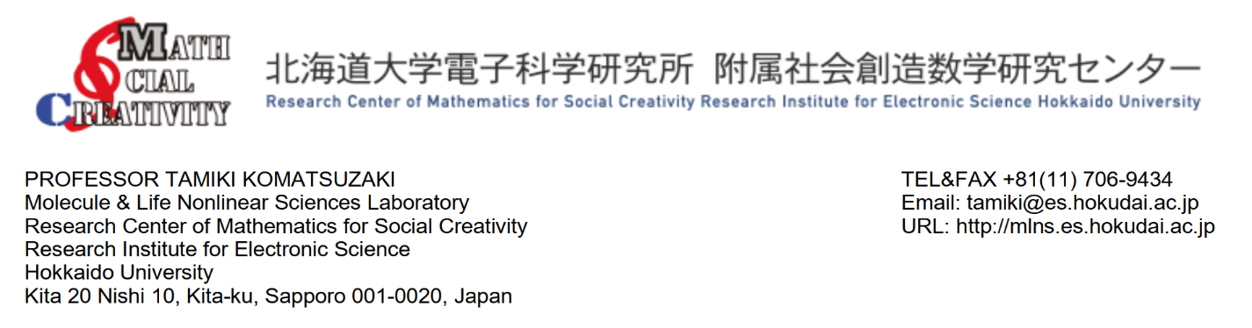 Date: October 12, 2023

To

The Registrar

Comilla University, Cumilla-3506, Bangladesh.

To Whom It May Concern

This is to certify that **Mr. Md. Mohiuddin**, doctoral course student, Faculty of Chemical Sciences & Engineering, Hokkaido University, Japan, is pursuing his Doctoral Program under my supervision. He is enrolled in this school as a full-time doctoral student since October 2021. He has already completed 1st & 2nd years and 3rd year is running on. He has successfully completed all the required courses in 1st year and presented two posters in two conferences (**listed below**). In my assessment, his performance in the courses offered by the school was excellent.

The duration for completing his Ph.D. degree under MEXT scholarship in this university is three years. I would like to recommend extending his study leave for more one year. Please do not hesitate to contact me if any further information is required.

I wish him every success in life.

Sincerely,

**Professor Tamiki Komatsuzaki**  
Molecule & Life Nonlinear Sciences Laboratory  
Research Center of Mathematics for Social Creativity  
Research Institute for Electronic Science (RIES)  
Hokkaido University  
The Institute for Chemical Reaction Design and Discovery  
(WPI-ICReDD)  
Kita 20 Nishi 10, Kita-ku, Sapporo 001-0020, Japan  
TEL&FAX +81(11) 706-9434  
Email: tamiki( at )[es.hokudai.ac.jp](http://es.hokudai.ac.jp/)  
URL: [http://mlns.es.hokudai.ac.jp](http://mlns.es.hokudai.ac.jp/)  
URL: <https://www.icredd.hokudai.ac.jp/>

**List of completed courses:**

* Leading and Advanced Materials Chemistry and Engineering II – 2022.
* Leading and Advanced Materials Chemistry and Engineering IB – 2022.
* Leading and Advanced Biological and Polymer Chemistry and Engineering II – 2022.
* Modern Trends in Physical and Material Chemistry.

**Poster presentation and conference attendance:**

* **Velocity field dynamics under blurring in fluorescent images of dictyostelium discoideum cells**. The 60th Annual Meeting of the Biophysical Society of Japan. September 28-30, 2022. Hakodate, Japan.
* **The development of causal relationship in dictyostelium discoideum cells**. Singularity Biology, 19th January 2022 (online).